Martian Solar Longitude at Selected Dates
Noah Hoblet

Ls calculation Source, using calculated earth days:
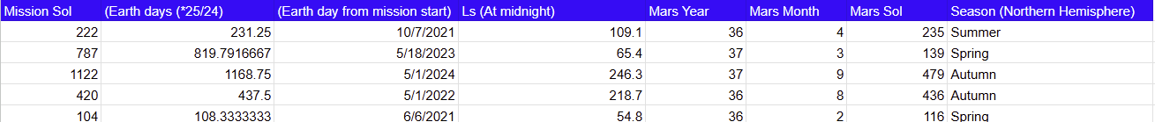
https://www-mars.lmd.jussieu.fr/mars/time/martian_time.html

Ls Confirmed by Secondary Source:
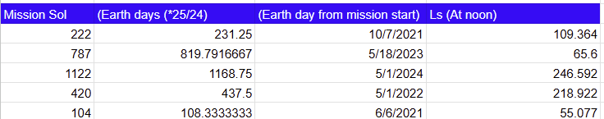
Ls from https://marsti.me/

Seasons source:
https://www-mars.lmd.jussieu.fr/mars/time/solar_longitude.html

Encountered Vortices:
- Sol 222 experienced 4 vortices in a clean and ordinary shape
- Sol 787 had an improper data point that was reverted to the value of 1 billion Pascals, with the data point excluded, a normal set of vortices appeared, numbering 10.
- Sol 1122 had 6 vortices and clean data
- Sol 420 had 4 vortices and clean data
- Sol 104 had 6 vortices and clean data

